Marriage: The Masks We Wear—Who Are We Really?
http://www.doingfamilyright.com/marriage-the-masks-we-wear-who-are-we-really/

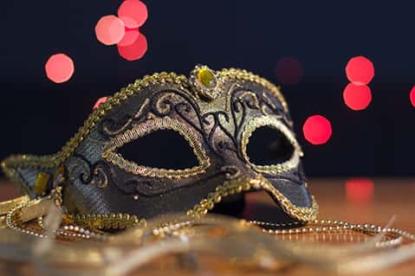
I spoke recently at a single Parent retreat. The topic was “Masquerade” and our tendency to put on masks… to pretend to be someone we aren’t. Occasionally this is because we are trying to figure out who we are or maybe we feel expectations or demands put on us to act or look a particular way.

The problem with masks is that they are not representative of who we truly are. They are images that we are left feeling we have to maintain.

I’ve also considered that many of us need to wear a lot of different hats. Different roles and tasks that are a part of our lives, are these hats, masks? How do we know if the hats we are wearing aren’t hats at all but a false persona we are expressing to the world around us?

As I considered this concept I realized that the primary difference between masks and hats is found in whether or not the people who know us in those different environments and roles, could meet each other, and still acknowledge that we are the same person.

Would you be afraid for them to meet each other? Would the stories they tell each other sound like they were talking about the same person?

The movie “Runaway Bride” with Julia Roberts comes to mind. She kept getting engaged and not showing up at the alter, all because she would become whoever the person she was with wanted her to be. But when her previous fiancés were asked about her, they had different stories and perceptions of who she was, down to the kind of eggs she liked. She was wearing masks that made her unrecognizable to others.

It’s not a problem for people to be surprised that we wear some of the hats we wear, if it simply adds to their perspective and completes a 3 dimensional view of who we are. It IS a problem if the person they know can’t be compiled into one personality. Like someone who says he or she loves to swim, but to someone else proclaims water is terrifying—the message conflicts and the 2 people are not one and the same.

The reason for our masks is almost always fear. Fear of rejection and judgment—ingrained into us is a deep need to make everyone around us happy. Fear of disappointing them is so deep that we pretend to be someone we aren’t.

The best place to find the freedom to discern who we are and live authentically is in Jesus. He provides for us the freedom of knowing we are loved, designed and created with a purpose and perfectly put together for His purposes. When we grasp our foundation and core identity in Him, the rest of our gifts, abilities and passions come together to form a complete person that is confidently living for Jesus and can live without the fear of disappointment or rejection because the only person’s opinion that really matters created us and loves us for who we are BEHIND the masks.

In the end it’s those of us who are assured in and of our identity that others are drawn, so the fake persona’s don’t actually help please anyone.
May you find that when you finally do shed the masks the world asks you to wear, you rise up as the person God created you to be.

P.S. Imagine the impact that living with a clear view of yourself and who you are will have on the relationships closest to you—your spouse in particular. Less pressure and expectations come out of a solid view of ourselves.

Its probably also worth noting that our children will model either our freedom to live as we were designed to by God, or our tendency to wear masks and hide ourselves from the world.

So, finding our value in God, our inventor and creator, is a win-win plan.

